Template for Evidence(s)
UI GreenMetric Questionnaire

University : ...
Country : ...
Web Address : …

[2] Energy and Climate Change (EC)

[2.9] Elements of Green Building Implementation as Reflected in All Construction and Renovation Policies

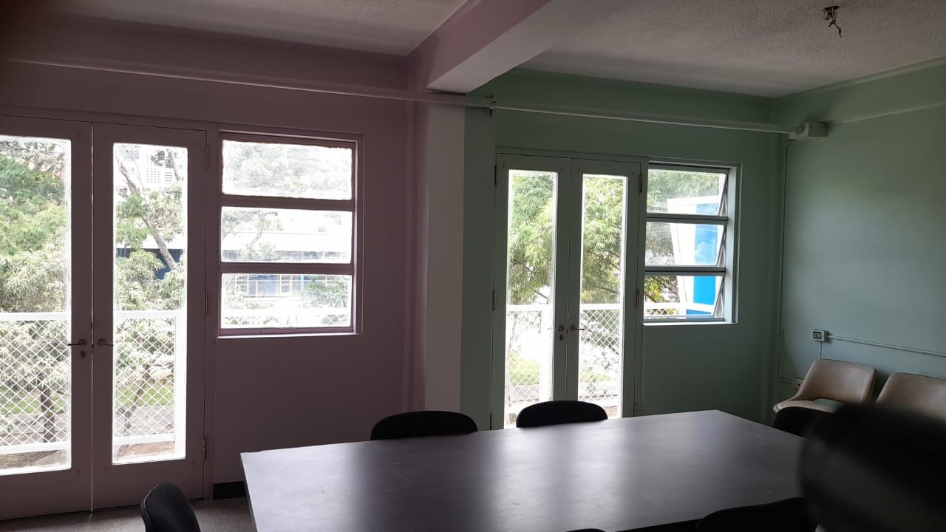
As part of the ongoing remodeling works at the Faculty of Medicine, windows air-conditioned appliances are being removed and replaced by open windows that let fresh air to get in.

Description:
(Please describe the elements of green building implementation on your campus. The following is an example of the description. You can describe more related items if needed.)

Additional evidence link (i.e., for videos, more images, or other files that are not included in this file):

