Template for Evidence(s)
UI GreenMetric Questionnaire

University : ...
Country : ...
Web Address : …

[2] Energy and Climate Change (EC)

[2.1] Energy Efficient Appliances Usage

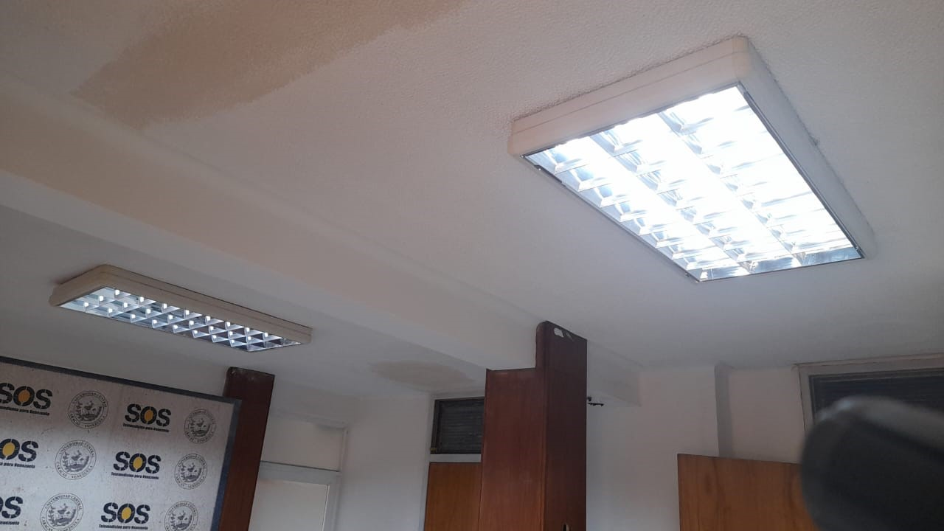
Example of Energy Efficient Appliances Usage: Use of LED lighting and lamps

Description:
(Please describe the energy efficient appliances usage on your campus. The following is an example of the description. You can describe more related items if needed.)

In many buildings at he Faculty of Medicine, incandescent and fluorescent lamps are being replaced by LED when they got burned.
Example:
Appliance | Total Number | Total number energy Efficient appliances | Percentage
LED Lamp | 3,000 | 1,200 | 40%
 |  | Average Percentage | 40%

Additional evidence link (i.e., for videos, more images, or other files that are not included in this file):

