Template for Evidence(s)
SAMPLE
UI GreenMetric Questionnaire

University : ...
Country : ...
Web Address : …

[1] Setting and Infrastructure (SI)

[1.21] Security and safety facilites

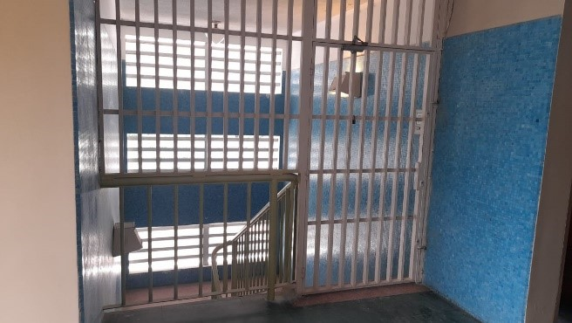 |  | 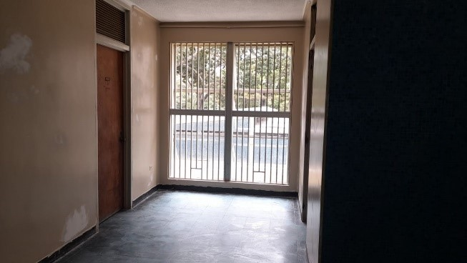
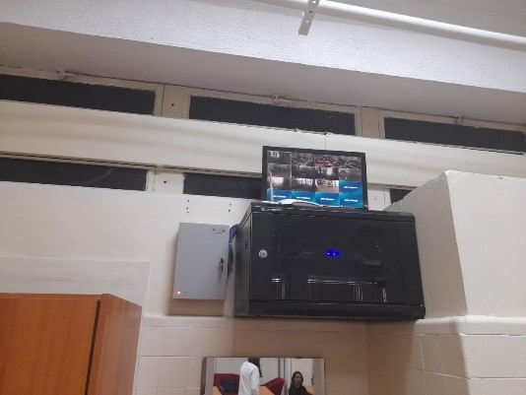 | 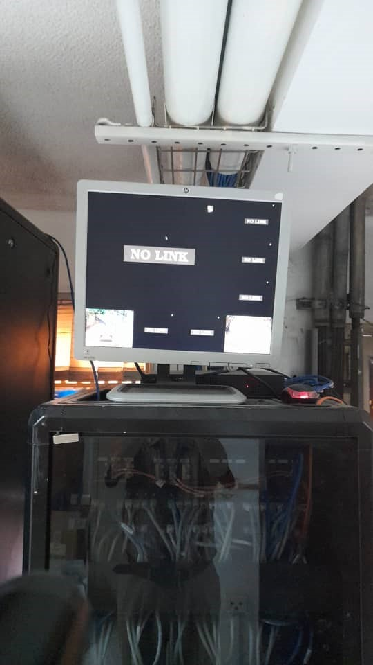
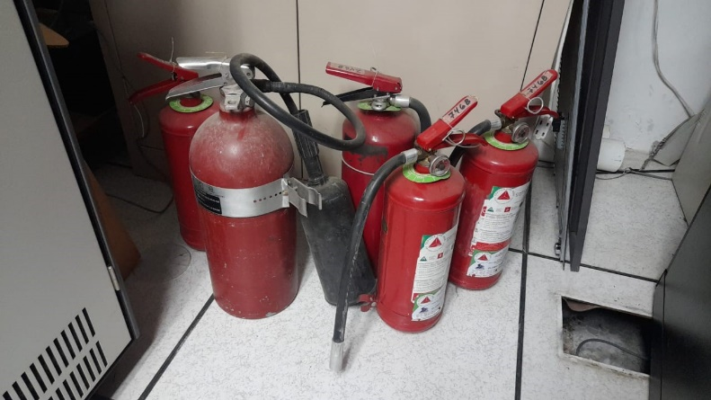

Description:
(Please describe the Security and safety facilites in your campus. The following is an example of the description. You can describe more related items if needed.)

- Passive securities in Telemedicine facilities
- Passive securities in Second floor in Luis Razetti School of Medicine
- CCTV in Anatomy Institute
- CCITV in Telemedicine. Only two cameras are shown operative due to ongoing remodetalion works.
- Fire extinguishers at the Luis Razetti School of Medicine. Operating condition is unknown.

Additional evidence link (i.e., for videos, more images, or other files that are not included in this file):

