Template for Evidence(s)
UI GreenMetric Questionnaire

University : ...
Country : ...
Web Address : …

[6] Education and Research (ED)
SAMPLE
[6.1] Number of Courses/Subjects Related to Sustainability Offered

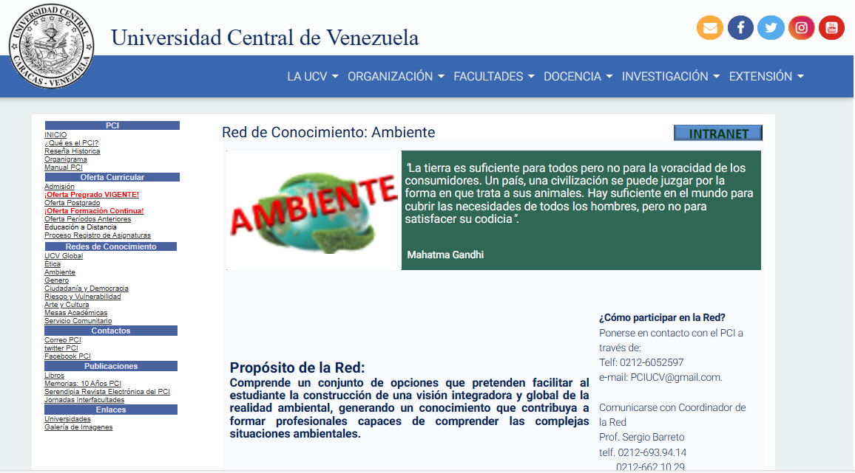
Environmental Knowledge Network, an initiative of the PCI (Interfaculty Cooperation Program)

Description:
(Please describe sustainability courses/subjects offered on your campus. The following is an example of the description. You can describe more related items if needed.)

No subject or course has sustainability in its programming. However, some professors include environmental issues in their classes, such as public health, although this can be considered an individual initiative since it is not contemplated in the academic program. However, through the ICP (Interfaculty Cooperation Program), students can take courses and carry out activities related to the environment in other faculties apart from ours through the Environmental Knowledge Network (ucv.ve)

Total number of courses with sustainability embedded for courses currently running: 10

Additional evidence link (i.e., for videos, more images, or other files that are not included in this file): http://www.ucv.ve/index.php?id=8798

