Template for Evidence(s)
UI GreenMetric Questionnaire

University : ...
Country : ...
Web Address : …

[6] Education and Research (ED)

[6.8] Number of Events Related to Sustainability

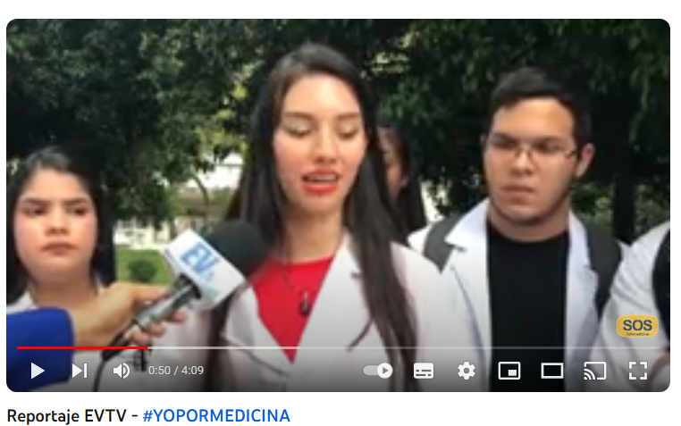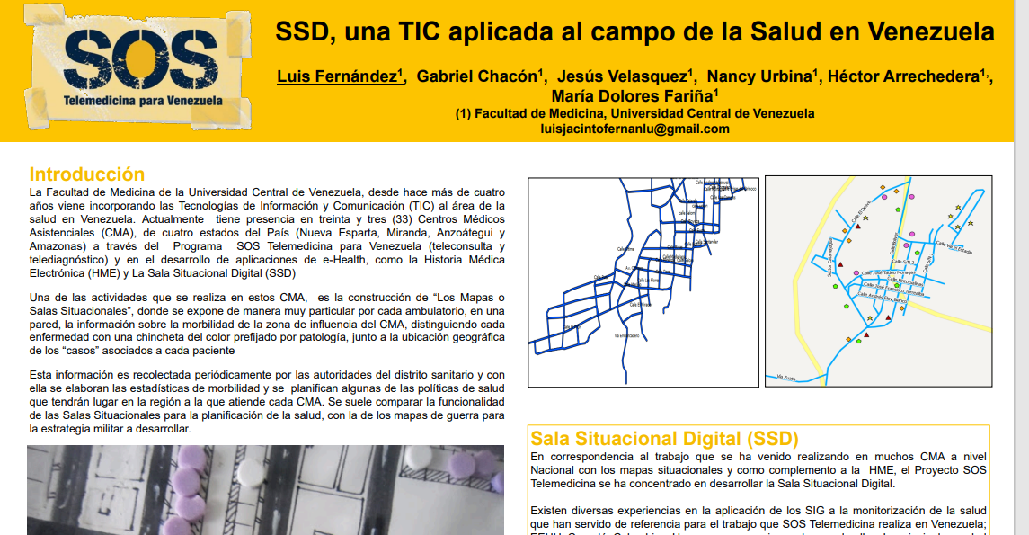
Examples of Events Related to Sustainability (Central University of Venezuela)

Description:
(Please describe sustainability events on your campus. The following is an example of the description. You can describe more related items if needed.)

Example of events related to environment and sustainability hosted or organized by the University in the academic year 2022-2023.
Total number of sustainability/environment related events in:
2022-23: 4
Additional evidence link (i.e., for videos, more images, or other files that are not included in this file):https://youtu.be/bbOLFuUO7zA?si=1JdE47ojtsJ7dfwJ

